**Skoovy Android App**

Hot Salsa Interactive LLC

Cole, Tyler; Kowal, Anthony; Matthews, Lilith; Wever, Rudi

**Coding Report: GitHub Home**

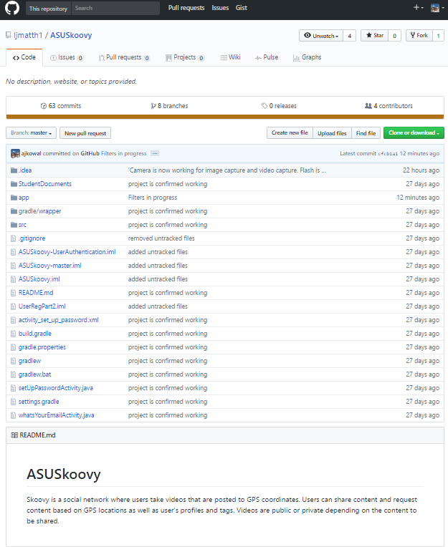

**Coding Report: GitHub Contributors**

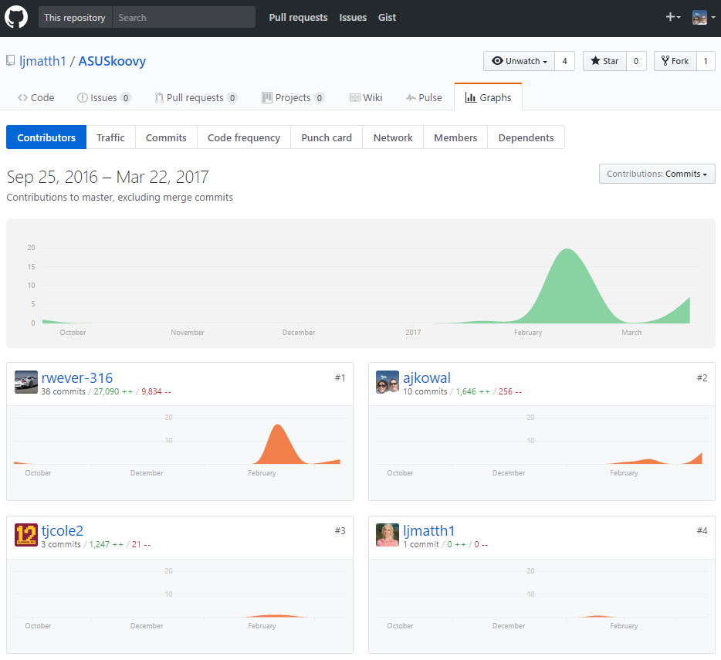

**Coding Report: Punch Card**

